Assignment 6

Marks for Assignment 6 total 80 (10 marks for each question).
- Answer the following questions:
- Draw the monofluorinated products formed in the greatest amount and the least amount when 1-methyl-1-(methylethyl)-cyclohexane is exposed to F₂ and UV light.
- Draw the complete mechanism for the formation of the major product above using single-barbed arrows to show the movement of a single electron. Label all the steps (chain-initiating and others).
- Are there any products possible that have no fluorine atoms present? Explain.
- For each pair of molecules, answer the question listed for S_{N}2 reactions :
- Identify the leaving groups present in each molecule below. Which is a better leaving group and why?
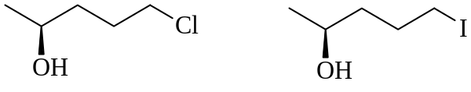
- Identify the most nucleophilic atom present in each molecule below. Which molecule is a better nucleophile and why?
CH₃-CH₂-O-Na CH₃-S-K
- Identify which reaction below would give the faster S_{N}2 reaction and
explain why.
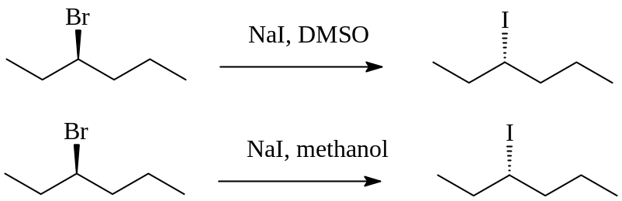
- The reaction below has been found to follow second-order kinetics.
- Predict the rate of reaction for Experiment #2 and Experiment #3 in the following table of experimental data.
Expt # | [CH₃Br]] in  mol•L^{–1} | [NaSCN] in  mol•L^{–1} | Rate in  mol•L^{–1}•s^{–1}
1 | 0.15 | 0.15 | 3.0 × 10^{–8}
2 | 0.15 | 0.45
3 | 0.30 | 0.15
- Clearly draw the mechanism for this reaction using curved arrows to show the movement of a pair of electrons. Identify the nucleophile and the leaving group.
- What would you expect to happen to the rate of reaction if methanol was used as the solvent instead of acetone?
- Answer the following questions for the reaction below:
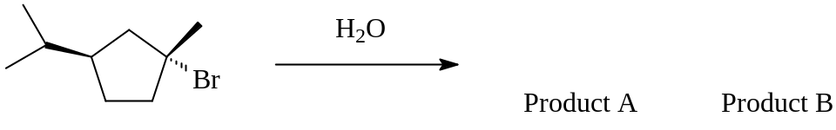
+ HBr
- Draw out the structures for the two substitution products possible from the above reaction.
- Explain why there are two products possible by drawing out the mechanism for this reaction using curved arrows to show the movement of electron pairs. Identify the leaving group and the nucleophile.
- Would you expect the two products A and B to be formed in the same amounts or would one be formed in greater amounts? Explain.
- Describe what effect (if any) that doubling the concentration of the nucleophile in this reaction would have on the reaction rate.
- Secondary alkyl halides can undergo substitution by different mechanisms, depending on the reaction conditions. Suggest suitable reaction conditions for a) and b), including nucleophiles and solvents, and draw the stereochemistry of the products.

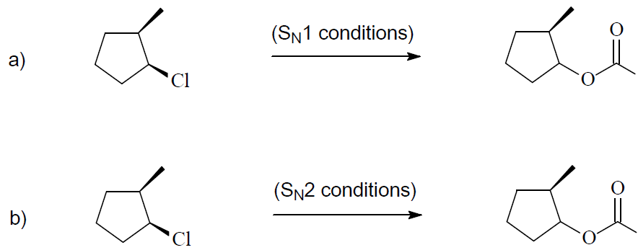

- Clearly and neatly draw the monobromination products from the radical halogenation of the molecule at the carbons indicated below (be sure to indicate correct stereochemistry). Answer the questions posed.
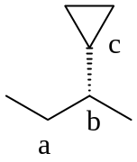
- Draw the 2 products from a monobromination at a, and briefly explain
which you would expect to be formed in the greatest amount.
- Draw the 2 products from a monobromination at b, and briefly explain
which you would expect to be formed in the greatest amount.
- Draw the product from a monobromination at c, and briefly explain
why only one product is formed.
- Predict the major organic product(s) for each of the following reactions. If there is no reaction, briefly explain why.
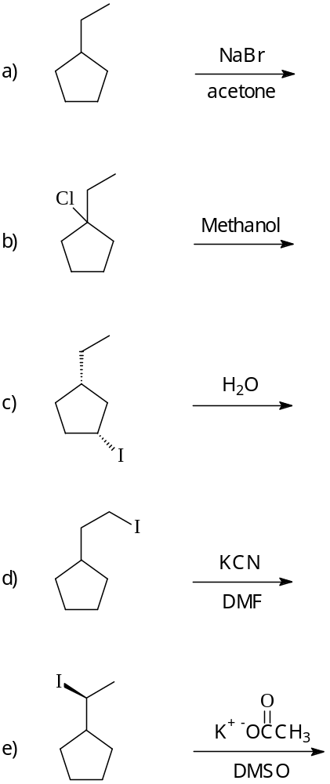
- Explain by means of reaction equations how you would synthesize each of the following compounds. Show reaction conditions, reagents, and solvents in your equations.
